Holiday Club at Home 2020 HEROES
MONDAY
Sing! Extraordinary Me Extraordinary You!
https://sameboatmusic.com/pages/sameboatmusicathome
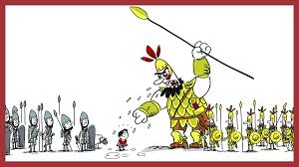
Sing this song every day and you’ll learn it really quickly!

The Story of David
https://www.bbc.co.uk/programmes/p05xgyxv

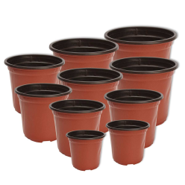
Outside challenge
Are you as good at throwing as David? Throwing at targets.
(Use flower pots of various sizes at different distances –you can score points for each
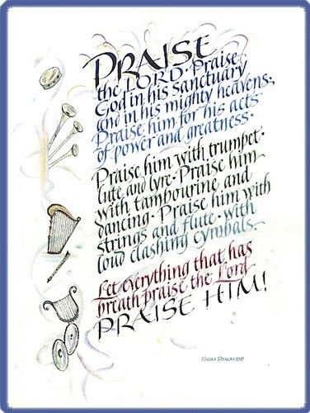
pot if you want to.)

Art and craft
David was a shepherd. Build a model sheep
Or
David was a musician. Make a musical instrument using boxes, rubber bands, empty bottles or anything else that you can find.
David was a composer. He wrote songs called psalms.
Can you write your own version of this psalm.

Cooking
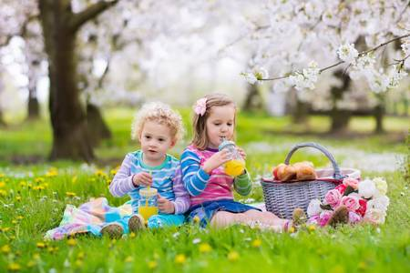
Make some giant-shaped or sheep biscuits. Or make cookies or jam tarts of differing sizes – from tiny to huge!

Picnic lunch in the garden with your family
Just enjoy !
TUESDAY
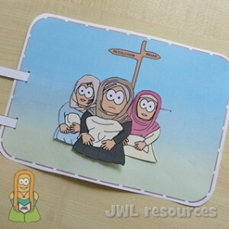
Sing!
Extraordinary Me Extraordinary You!
https://sameboatmusic.com/pages/sameboatmusicathome

The Story of Ruth and Naomi
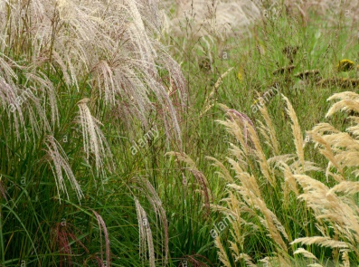
https://www.youtube.com/watch?v=___5ppDVbUs
Outside challenge
Be a collector like Ruth.
Collect one each of… different flowers , types of grass,
or types of leaf from the garden.
Can you find all the colours of the rainbow?
Who can find most?
Health warning ! Remember to wash your hands after touching the plants
Art and craft
Find pictures in magazines of people who look different from each other
eg rich and poor, old and young, black and white disabled etc.
Cut them out and make a collage to show that we are all God’s people.
You can add a few words to help get the message across
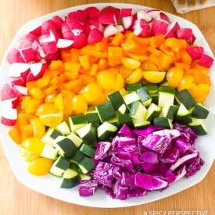
Cooking
Make some flatbreads and eat them for lunch with a beautiful rainbow salad.
https://www.bbc.co.uk/food/recipes/quick_flatbreads_43123

Picnic lunch in the garden with your family
Just enjoy !

WEDNESDAY
Sing!
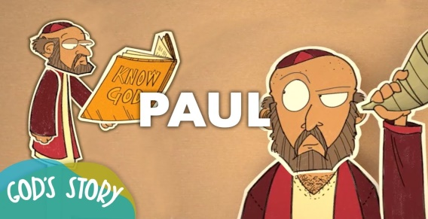
Extraordinary Me Extraordinary You!
https://sameboatmusic.com/pages/sameboatmusicathome

The Story of Paul
https://www.youtube.com/watch?v=R0p0W_Zbt1s

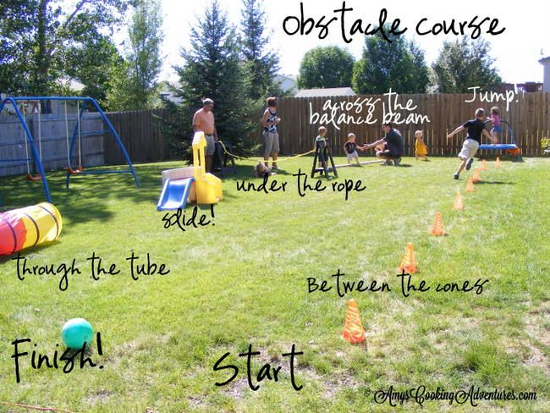
Outside challenge
Paul had to face a lot of challenges
Make an obstacle course in your garden to represent all the challenges that Paul had to overcome.
How fast can you get round it?
Challenge your family to beat your time!

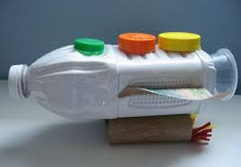
Art and Craft
Make a model boat out of junk. It must float.
Or make a picture map of Paul’s journey with as many amazing challenges as you like.
Or make a poster about a present day hero.

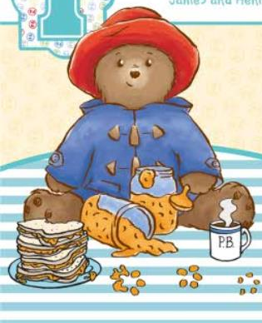
Cooking
Make orange jelly boats. They won’t be set till tea time or tomorrow.
https://thehappyfoodie.co.uk/recipes/party-jelly-boats
Prepare a surprise lunch for your family.
Invite your parents or carers to say thank you for looking after you as well as your brothers and sisters (and maybe invite a bear or two!).
Picnic lunch in the garden with your family
Just enjoy!

